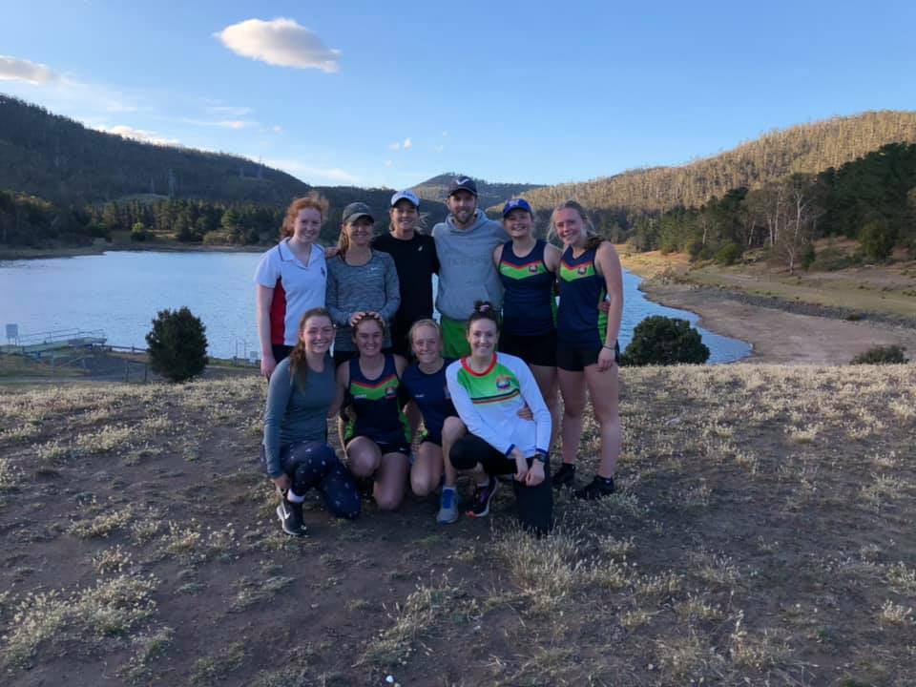
Jan2020
Sun | mon | tue | wed | thu | fri | sat
 |  |  | 01 | 02 | 03 | 04
 |  |  | Own session |  |  | Own session
05 | 06 | 07 | 08 | 09 | 10 | 11
 | Own session |  | TRAINING  Natone Hill  6pm – 7pm |  |  | Own session
12 | 13 | 14 | 15 | 16 | 17 | 18
 | TRAINING  Lower Sandy Bay  6pm – 7pm |  | Own session |  |  | TRAINING  Squash Bellerive  8am – 9am
19 | 20 | 21 | 22 | 23 | 24 | 25
 | TRAINING  Risdon Brook  6pm – 7:30pm |  | TRAINING  Cornelian Bay  6pm – 7pm |  |  | Australia Day  Own training
26 | 27 | 28 | 29 | 30 | 31
 | TRAINING  Bellerive Beach  6pm – 7pm |  | TRAINING  Mt Nelson Steps  6pm – 7pm
Notes
Own cardio sessions must be completed prior to the pre-season calendar starting. We encourage you to post your workouts on Facebook to keep everyone up to date and to encourage others to get active. |  |  |  | ***** It is likely that the Saturday turf sessions will be as set out in the calendar, but we will confirm once we know.

